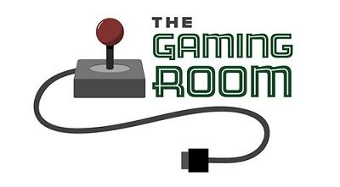

Draw It or Lose It

CS 230 Project Software Design Template
Version 1.1

Table of Contents

CS 230 Project Software Design Template 1
Table of Contents 2
Document Revision History 2
Executive Summary 3
Requirements 3
Design Constraints 3
System Architecture View 3
Domain Model 4
Evaluation 4
Recommendations 8

Document Revision History

Version | Date | Author | Comments
1.0 | 07/19/2026 | Blake Merry | Initial software design and Java prototype for Project One.
1.1 | 08/02/2026 | Blake Merry | Project Two revisions to the Development Requirements table.

Instructions
Fill in all bracketed information on page one (the cover page), in the Document Revision History table, and below each header. Under each header, remove the bracketed prompt and write your own paragraph response covering the indicated information.

Executive Summary

The Gaming Room currently offers Draw It or Lose It as an Android application and wants to expand the game so that it can be played on other platforms. In each game, teams compete through four timed rounds by guessing images as they’re gradually rendered. The web-based version will need to support multiple games, teams, and players while making sure that game and team names aren’t duplicated.

The Gaming Room should move Draw It or Lose It to a web-based distributed application. Instead of developing and maintaining a separate application for every operating system, uses could access the game through a web browser on Windows, macOS, Linux, Android, or iOS. A central server would manage the game rules and shared data so that every player sees the same teams, images, timers, and scores. The Java prototype is a starting point by organizing games, teams, and players into classes with unique identifiers. It also prevents duplicate names and makes sure all active games are managed through the same service. Before future development, The Gaming Room will need to choose a server platform, data storage system, and security methods based on the number of players it expects it will support.

Requirements

Draw It or Lose It must be converted from an Android-only application into a web-based game that can be accessed from multiple operating systems. A game must support one or more teams, an each team must be able to include multiple players. Game and team names must be unique so that users can determine whether a name is already being used. Every, game, team, and player must also get a unique identifier. A single instance of the GameService class will manage the List of active games and assign identifiers as new Entities are created. The web version must also preserve the basic structure of the original game, including four one-minute rounds, images that are gradually rendered as clues, and the opportunity for other teams to guess when time expires.

Design Constraints

One of the biggest design constraints is that Draw It or Lose It must work as a web-based distributed application instead of an Android-only application. A central server should manage the game rules, teams, players, timers, guesses, and image library, while users interact with the game through a web browser on a difference desktop or mobile device. Because multiple players may interact with the same game at nearly the same time, the server must maintain a consistent game-state and prevent conflicting updates, such as two users claiming the same team name. The image library also creates processing, memory, and network overhead, so images should be compressed and cached when appropriate, and resources associated with completed games should be released from memory. Information that should survive an application restart will require persistent storage. Communication should be protected with HTTPS, and user input should be validated before it’s processed. Together, these constraints affect how the application manages shared data, responds to multiple users, and remains secure and responsive cross-platform.

System Architecture View

Please note: There is nothing required here for these projects, but this section serves as a reminder that describing the system and subsystem architecture present in the application, including physical components or tiers, may be required for other projects. A logical topology of the communication and storage aspects is also necessary to understand the overall architecture and should be provided.

Domain Model

The domain model shows how the main parts of Draw It or Lose It are organized. Entity is the base class for Game, Team, and Player and contains the id and name attributes they all share. GameService manages the collection of active games, each Game contains multiple Teams, and each Team contains multiple players. Inheritance and abstraction allow the three subclasses to reuse the common attributes and methods defined in Entity, while encapsulation keeps those attributes private and provides controlled access through getters like getId() and getName(). Each subclass also overrides toString() through polymorphism. The singleton pattern limits GameService to one instance so that games and unique identifiers are managed consistently, while the iterator pattern searches existing collections before adding a game, team, or player. If a name is already in use, the existing object is returned instead of creating a duplicate.

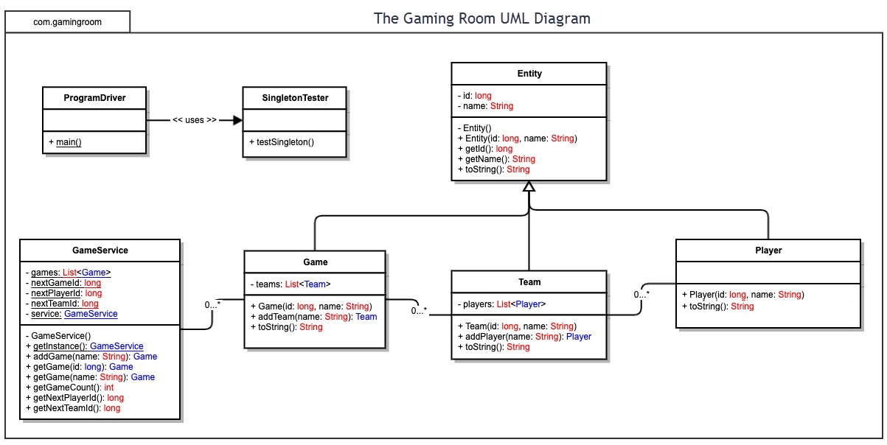

Evaluation

Using your experience to evaluate the characteristics, advantages, and weaknesses of each operating platform (Linux, Mac, and Windows) as well as mobile devices, consider the requirements outlined below and articulate your findings for each. As you complete the table, keep in mind your client’s requirements and look at the situation holistically, as it all has to work together.

In each cell, remove the bracketed prompt and write your own paragraph response covering the indicated information.

Development Requirements | Mac | Linux | Windows | Mobile Devices
Server Side | macOS can host the Java web application using the JDK with a server such as Jetty, Tomcat, or Spring Boot, and it can also run common web-server and database software. Its Unix-based design provides many of the same command-line and networking tools available on Linux. However, macOS must run on Apple hardware, which raises hardware costs and provides fewer data-center and cloud-hosting choices. The operating system is included with the Mac rather than licensed separately, but the platform is less practical for scaling Draw It or Lose It to thousands of players than Linux or Windows Server. | Linux is well suited for hosting Draw It or Lose It because it is stable, efficient, and widely supported by Java web servers, containers, databases, load balancers, and cloud providers. The application could run directly on a Linux server or inside containers that can be replicated as demand increases. Community distributions such as Ubuntu Server can be used without an operating-system licensing fee, although paid enterprise support is available if the client needs it. The main weakness is that deployment, security hardening, monitoring, and troubleshooting require administrators with Linux experience. | Windows Server can host the Java application through Jetty, Tomcat, Spring Boot, or another Java server, with IIS available as a reverse proxy in front of the application. It offers familiar graphical administration, Active Directory integration, PowerShell automation, and strong support in Microsoft Azure. Its primary disadvantage is cost: Windows Server uses commercial core-based licensing and may require additional access licenses depending on the deployment. It also generally uses more system resources than a minimal Linux server, but it remains a capable choice for an organization already invested in Microsoft systems. | Android and iOS devices can technically run limited web-server software, but they are not appropriate production servers for Draw It or Lose It. Mobile operating systems restrict background processes, devices may change networks or lose connectivity, and battery life, heat, storage, and memory limit reliability and scalability. Mobile platforms also lack the normal server-management, redundancy, and monitoring capabilities needed for thousands of players. Although there is no separate server operating-system license, these limitations make mobile devices useful only as clients or temporary development test systems.
Client Side | Mac users can access the game through Safari, Chrome, Firefox, or another modern browser, so a separate macOS application is not required. The client should use standards-based HTML, CSS, and JavaScript with a responsive layout and keyboard accessibility. The development team must still test Safari and its WebKit engine because behavior can differ from Chromium and Firefox, especially for media, full-screen features, and newer web APIs. This adds testing time and may require Mac hardware, but it should not require a separate development team. | Linux clients can use the same responsive web interface through browsers such as Firefox and Chromium. Standards-based development keeps platform-specific work low because the server, rather than the client operating system, remains responsible for game rules and shared state. Testing should cover the major browser engines and common display scaling, keyboard, and audio configurations. The team does not need to test every Linux distribution because browser compatibility matters more than the underlying distribution, which keeps the additional cost and development time relatively small. | Windows clients can run the game through Edge, Chrome, Firefox, and other modern browsers. The team should test the current versions of the major browser engines along with common screen sizes, display scaling settings, keyboard and mouse input, and touch-enabled devices. Using one responsive web client avoids maintaining a separate Windows build and allows most defects to be fixed for every platform at once. Windows has a large range of hardware and input configurations, so it will still require broad quality-assurance testing even though platform-specific coding should be limited. | The mobile client should use a responsive, touch-friendly HTML interface that adapts to small screens, portrait and landscape orientation, different pixel densities, and accessibility settings. It must also handle slower or interrupted connections by reconnecting to the server without losing the current game state. Testing is needed on both iOS Safari and Android Chrome using emulators and real devices because their browser behavior and resource limits differ. This will require more design and testing time than desktop support, but native Swift and Kotlin teams are unnecessary because the client remains web based.
Development Tools | Mac development can use the JDK, Maven, Git, VS Code, Eclipse, or IntelliJ IDEA for the Java server and HTML, CSS, JavaScript, or TypeScript for the browser client. Safari Web Inspector and Responsive Design Mode are important for testing Safari, while Xcode supplies iOS simulators if needed. Most of these tools have free versions, although commercial IDE editions, testing services, and Apple hardware can add cost. At least one Mac should be available to the shared development or quality-assurance team for reliable Safari and iOS testing. | Linux supports OpenJDK, Maven, Git, VS Code, Eclipse, IntelliJ IDEA, Docker or Podman, and Java frameworks and servers such as Spring Boot, Jetty, and Tomcat. Most of this toolchain is open source and can be used without licensing fees, making Linux a cost-effective environment for development, automated testing, and production deployment. The same team can build the server and cross-platform web client, although someone must have Linux administration, container, networking, and deployment experience to maintain the production environment securely. | Windows development can use the JDK, Maven, Git, VS Code, Eclipse, IntelliJ IDEA, PowerShell, WSL, Docker, and browser developer tools. The Java application can run on the same cross-platform frameworks used for Linux and macOS, so a separate Windows development team is not necessary. Free editions are available for most tools, but Windows, Windows Server, some IDE editions, and commercial container or testing products may create licensing costs. The team also needs Windows expertise if it chooses IIS, Active Directory, or Azure-specific deployment features. | Mobile web development uses the same HTML, CSS, JavaScript, or TypeScript code as the desktop client, often with a responsive framework such as Bootstrap, React, or Vue. Chrome DevTools and Android emulators can test Android behavior, while Safari Web Inspector and the iOS Simulator require access to macOS. The tools are largely free, but real test devices, Apple hardware, and optional cloud-based browser testing can add cost. A separate native-app team is not required, but the project should include responsive-design expertise and dedicated cross-device testing.

Recommendations

Analyze the characteristics of and techniques specific to various systems architectures and make a recommendation to The Gaming Room. Specifically, address the following:

- Operating Platform: I recommend Linux as the server platform because it’s stable, cost-effective, widely supported, and well suited for hosting Java web apps.

- Operating Systems Architectures: A 64-bit Linux server can support large amounts of memory and efficiently manage multiple processes at once. Its multi-user architecture and permissions system also allow the game service to run separately from other applications and administrative accounts.

- Storage Management: SQL would provide reliable persistent storage for users, games, teams, and scores, while the image library could be stored separately in a file or object-storage system.

- Memory Management: Linux uses virtual memory and paging to distribute physical memory among running processes, while the Java Virtual Machine uses garbage collection to reclaim objects the application no longer needs. The game should also release completed sessions and limit image caching so it doesn’t consume memory unnecessarily.

- Distributed Systems and Networks: Browser clients can communicate with the central server through HTTPS requests and Web Socket connections, allowing game updates to reach different platforms in near-real time. The server should be the authoritative source for game-state and provide reconnection behavior when users experience network interruptions.

- Security: User information should be protected with HTTPS encryption, secure authentication, validated input, and role-based access controls. The Linux server should also receive regular security updates, run the application with limited permissions or within a container, and use firewall rules to expose only the network resources users need.

